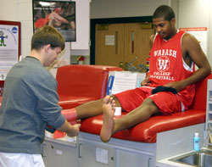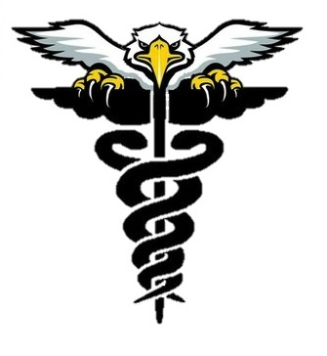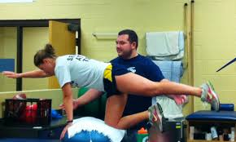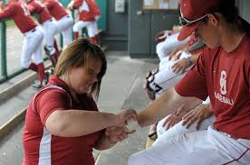

Supporting Eagle Athletics and Programs

Eagle Athletes

Mrs. Katie Szymczak

Instructor and HHS First Responder  
katie.szymczak@usd210.org

BS – Phys Ed from The Ohio State University

MS – Health and Human Performance from Fort Hays State University

[Your Phone]  
[Web Address]

HHS

Eagle

trainers

Prevent, Manage Recognize & Treat

215 W. 11th Street

Hugoton, KS 67951

(620)544-4311

HHS Sports Med Program

##### “If you: break it, sprain it, strain it, bruise it,

##### or lose it…we will: ice it, tape it, wrap it, heat it,

##### stretch it, cut it off, or find you a new one!”

### Sports Med Program

## Care and Prevention of Athletes

#### At HHS, we offer Care and Prevention of Athletes (Sports Medicine) to our students. Students have an opportunity to also take this as concurrent SCCC elective credit.

Sports Med

BECOME AN EAGLE ATHLETIC TRAINER!

**Course Description:**

Teaches students components of sports medicine, including exploration of the following: therapeutic careers, medical terminology, anatomy and physiology, first aid, injury prevention principles, the healing process, rehabilitation techniques, therapeutic modalities, sports nutrition, sports psychology, and performance enhancement philosophies.  Available to students in Grades 11-12.

**Topics Covered in 2014-15**

* Introduction, Sports Med Team and Roles, The Foot, Health Care Organizations, Ankle and Lower Leg
* Protective Equipment, Knee, Bandaging and Taping, and the Thigh, Hip, and Groin
* Psychosocial Intervention, Shoulder, On the Field Acute Care, The Elbow, and Infectious Diseases
* The Forearm, Wrist, and Hand, Pharmacology and Drugs, The Spine, Head, and addt’l projects and presentations.

Every student becomes a Student Athletic Trainer for HHS. Students will be responsible for training a specific sport or activity at HHS.

Sports Medicine allows students an opportunity to receive an elective credit through HHS and SCCC if they so choose.

Who should take it?

ANYONE – but specifically students looking to enter the sports medicine field:

* Athletic Training
* Medical Doctors
* Nurses
* Nutrition/Dietetics
* Physical Therapy & more

HHS Sports Med

###### What we do: